**Unix System Programming**

**Project – Hospital Database**

**Abstract:**

Hospital Management System is a typical software which is used as a front desk help for hospital. Here, we can know various kinds of details which is required at the hospital. In olden days, there were records with manual entry. As now, there are enormous technologies evolving, every aspect is going to be computerized and modernized. This Hospital Management System is basically developed on Unix Environment with small instructions. The help desk can use this information for many purposes such as to find out the how many rooms have been allocated, what is the name of the patient, what is the name of the doctor etc.

**Database for Hospital Management System:**

Here Database is nothing but the text files which is used to store the data and have DML functions.

1. Patient Database
2. Doctor Database
3. Rooms Database
4. Building Database
5. Admitted patience Database
6. Pharmacy Database
7. Pharmacy prescriptions Database

Some of the databases over here have a unique key value which cannot be left blank or null.

The main file is named as Hospital.sh. When we execute the program, we get many options and we can follow the instructions line by line.

The below is the attachment of Hospital.sh file.



When we execute this file, a folder named Hospital will be created. If the software is first used, we have empty database. So, create plain text file containing no data with the above database names.

The below is the screen shot of the above explanation.

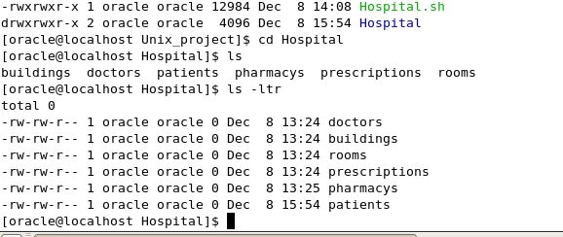

Now, we try to execute the code and add some data to them.

To execute the file, please follow the below snapshot:

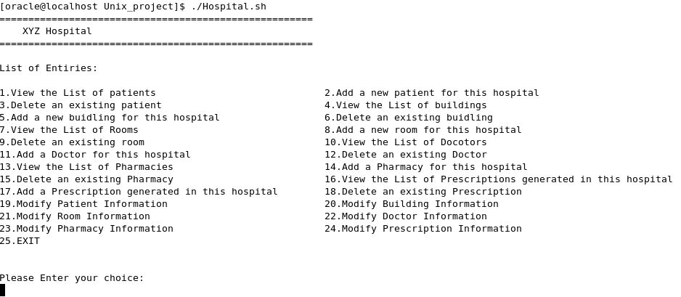

As, we enter the choice, we have multiple functions over to do. Now, for example we try to list the patients and add some patients. Below are the screenshots:

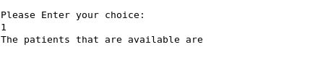

The above screenshot is empty as there are no patients available.

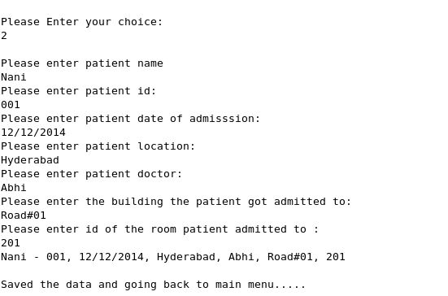

In the above option, we have entered one patient data. Now, let us see if the data is available of the above person.

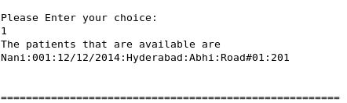

Now, we can see the details of patient admitted with unique id, name, doctors name, date and room.

Likewise, we can have any function done with the help of List of entries which are displayed while we run the code.